Whose Side Are You On?
And if a house be divided against itself, that house cannot stand – but can you think of a more divided sector than ours? Despite shining exceptions on the whole we’re divided internally, divided from our partners, divided from the public, and (unforgivably) divided from those we serve.

One in six charities fear closure this year. This apocalyptic scenario should force us to question these divisions.

Questions about ourselves…

When did we lose sight of the big picture?
Different departments work on different campaigns with different agencies. But when did it become ok to think in internal, territorial terms about "my donors"? When did we fall for the delusion people were supporting our department? If we don’t integrate how can we effectively communicate?

When did we start thinking they supported ‘us’?

Why do so many charities ask for support for the organization rather than the abused animal, the starving child, or the dying teenager? I’m in the privileged position of being able to listen to countless conversations across every type of campaign for just about any cause you can think of. To this day I’ve never heard anyone say they support an organization. Ever. What I have heard is deeply moving testimonials as to why they support the people that they do.

If you took a Pepsi challenge style test and listened in on anonymised conversations between “your” supporters and those of a charity with a similar goal it’d be impossible to tell who supported who.

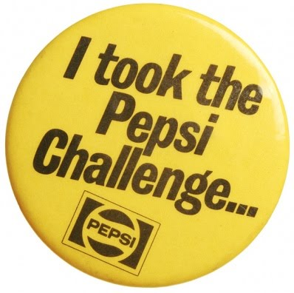

When did it become about means rather than end?
It’s easy to get caught up in the hype of a new campaign, re brand or innovative technology. But none of these things mean much to the public. It may come as a shock but I’ve never once heard someone refer to the rebrand or how engaged they are with the channel. In our rush to catch their eye we fail to capture their hearts.

Questions about our partners…

When did we stop trusting each other?
Could we label ourselves any more divisively than ‘client side’ and ‘agency side’? Is that really how we think of ourselves? Surely the only side we’re on is the beneficiaries?! The idea that someone who works for an agency is cynically money driven is as naive (and insulting) as the idea that someone who works for a charity knits their own tofu and grows their own sandals!

When did we stop engaging with our frontline fundraisers?
Your street or telephone fundraiser will probably have more conversations with the public about your work in a day than your head of fundraising will have in a year. But they can only work with what they’re given. If you don’t invest time and money inspiring them how are they to inspire others?

Questions about the public…

When did we stop listening?
Over the years charities espousing ‘relationship fundraising’ have built huge files of rejecters. But do we let the fact that they’ve said ‘no’ to increasing or changing their method of support for over a decade deter us from asking again (and again, and again)? Of course not! It’s time we redraw those patronizing pen portraits and replace ‘Regular Giving Rachel’ with ‘Pissed off Penny.’

When did we start thinking for them?
What do we really know about the people who gave or give us money? Have we ever looked into what really drove commitment and ways to influence that? We’re presiding over the nadir of donor loyalty. Why do we continue to hammer the same Recency, Frequency, Monetary Value model as though all this were just a bad dream? (Those who want an answer should come to ‘The Summit’ this April).

When did we stop saying thank you?
Firstly ‘thank you’ is just good manners. Secondly it’s good sense. The lifetime value of your database could be enhanced by 200% with just a 10% increase in loyalty. Loyalty programmes are not theory; they’re proven to work, so why aren’t we investing in them?

Questions about our beneficiaries…

The saddest division of all lies between the sector and those it exists to serve. It’s a subject I wrote about last year. If I’m not engaged how can I engage with my colleagues, my partners and the public?

Of course the answer to all these questions lies in the questions themselves.

In such extraordinary times it’s worth remembering the origins of the name of our sector. The word ‘charity’ first appeared in the English language in the Kings James bible translation of Paul’s first letter to the Corinthians. It’s worth looking at a couple of lines and asking the question whether they apply to us anymore.
‘…charity envieth not; charity vaunteth not itself, is not puffed up. Doth not behave itself unseemly, seeketh not her own…’

