**Dutch Cancer Society recruits 50.000 donors via a Telethon**

2010 was for [KWF](http://translate.google.com/translate?hl=nl&sl=nl&tl=en&prev=_t&u=http://www.kwfkankerbestrijding.nl/), the Dutch Cancer Society, a very special and historic fundraising year. We reached € 100 million income from fundraising and recruited 115.000 new structural donors. A record in the history of KWF, which is the largest NGO

in the Netherlands based on income from fundraising. [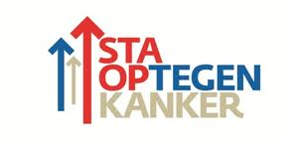](http://www.101fundraising.org/wp-content/uploads/2011/02/foto-logo2.jpg)One of the highlights in 2010 was the fundraising TV show "Stand Up To Cancer" which generated 50.000 new structural donors. This was the fourth fundraising TV show since 2006. This last one exceeded everyone's expectations except our host Ruben Nicolai, a Dutch celebrity: he opened the show with his personal dream of 50,000 new donors, which is more than twice the result of the show in 2009. Our host proved to be very prophetic.

**Stand Up To Cancer (SU2C)** [Stand Up To Cancer](http://www.standup2cancer.org/)In November 2010 the Dutch people rose en masse against cancer and became a donor. If you missed the TV show, it can still be viewed via [this link](http://translate.google.com/translate?hl=nl&sl=nl&tl=en&prev=_t&u=http://player.omroep.nl/%3FaflID%3D11728214) or search within [YouTube](http://translate.google.com/translate?hl=nl&sl=nl&tl=en&prev=_t&u=http://www.youtube.com/results%3Fsearch_query%3D%25E2%2580%2598Sta%2Bop%2Btegen%2Bkanker%25E2%2580%2599%26aq%3Df) for 'Sta op tegen kanker’ to watch various fragments.

The format for the TV show has been adopted from the US and adjusted for the Netherlands. [SU2C](http://www.su2c.org/) is an initiative created to accelerate groundbreaking cancer research that will get new therapies to patients quickly and save lives. SU2C's goal is to bring together the best and the brightest in the cancer community, encouraging collaboration instead of competition. SU2C is a program of [The Entertainment Industry Foundation](http://www.eifoundation.org/) , a leading charitable organization of the entertainment industry in the US.

At the beginning of the TV show it was visualized in a clear manner that everyone has a relationship towards cancer. Personal stories from famous Dutch people and their relationship towards cancer were the central theme. Are they touched because loved ones have cancer? Or have they lost someone because of cancer? The open statements were a common thread in the program. Furthermore there were touching stories from patients and special live performances from Dutch celebrities.

But it was more than a 90 minutes TV show. There was a huge buzz in advance to involve as many people upfront.

*[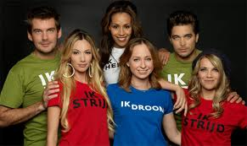](http://www.101fundraising.org/wp-content/uploads/2011/02/foto-lied.jpg)* *Some examples:* - The campaign song ['Just Stand Up "](http://translate.google.com/translate?hl=nl&sl=nl&tl=en&prev=_t&u=http://www.youtube.com/watch%3Fv%3DUyGXXIkINjA) did generate a lot of publicity and the famous Dutch singers used also their own social networks to raise awareness

- Hans van Breukelen (goalkeeper of the Dutch National Soccer team who became European Champion in 1988) made during a soccer game [an impressive appeal](http://translate.google.com/translate?hl=nl&sl=nl&tl=en&prev=_t&u=http://www.youtube.com/watch%3Fv%3DF8GCbgA8WxE) to the audience in a full stadium to stand up and not to use the word "cancer" anymore, which unfortunately happens too much in soccer stadiums in the Netherlands. The whole stadium reacted positive and stood up. A truly magical moment!

[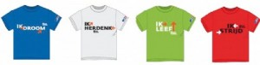](http://www.101fundraising.org/wp-content/uploads/2011/02/foto-t-shirts.jpg)- A famous Dutch singer made an appeal in several media to write a special ‘cancer-related’ song text on the melody of one of his greatest hits. In the live show he did sing this song exclusively.

- Employees of a lot of shops wore a special shirt in the week before.

[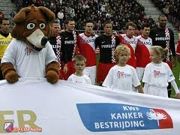](http://www.101fundraising.org/wp-content/uploads/2011/02/foto-stadion.jpg)Besides all the publicity to create a buzz , in the week before the TV show several actions took place to recruit donors directly.

*Some examples:* - launch of a new website - direct dialogue - a direct mailing the day after - several telemarketing activities such as endorsed calls on the fan base of the soccer teams after the earlier mentioned impressive appeal in the stadium

**The result: more than gross numbers of donors** 1,136,000 viewers and 50,000 new structural donors. This means a conversion rate of more than 4% which is absolutely overwhelming. This allows us to fund a lot of scientific cancer research and perhaps this will make a big difference for many people.

The ROI (return on investment) can be expressed in weeks and is by far the most important key performance indicator. But please don’t look only at the gross numbers, there’s more in life and the impact is much bigger:

- first of all, it has stimulated international co-operation between organizations which want to unlock the answers that will finally conquer cancer and I hope that this will stimulate more international joint efforts; - it is my experience that the churn of these TV-donors is lower than donors recruited via other channels, thus above average expected lifetime value;   
- the TV show did increase the result of other fundraising actions substantially: the direct mailing the day after had an far above-average response rate, the direct dialogue recruiters did have a much higher productivity, TM actions scored better, several people did start a fundraising action on the new website and it will definitely stimulate others to make a contribution;   
- the show did support a lot of people, we have received many wonderful responses from patients and volunteers;   
- lots of free publicity and further strengthening brand awareness and [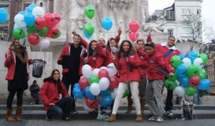](http://www.101fundraising.org/wp-content/uploads/2011/02/DSCF1564.jpg)image;

**What were the success factors?** The prediction of the success of fundraising TV shows remains a difficult phenomenon. We have been very successful now, but certainly had also less successful TV shows in the past. I will try to describe what made this telethon so special.

*Incredible inspiration and passion of many people* It starts with unconditional enthusiasm, passion and commitment. The engine behind many beautiful things. There were so many people inside and outside KWF who made a contribution with so much enthusiasm. All the people involved got so touched and did everything they could to achieve the best possible result ever. It did result in such a powerful and dynamic energy, a vibe which I had never experienced in or outside KWF.

*Feeling of a national evening* The format is of course crucial. Thanks to the wonderful co-operation with [The Entertainment Industry Foundation](http://www.eifoundation.org/) we could develop an adjusted concept for the Netherlands. But this would not have happened if the production company [I Care](http://translate.google.com/translate?hl=nl&sl=nl&tl=en&prev=_t&u=http://www.icareproducties.nl/) did not show us the DVD of the TV show in the US. It was definitely not a standard fundraising format but innovative, a lot of variety, speed, very personal and direct, confrontation and hope.  
It was a show that created a feeling of national evening, it did touch people right in the heart and showed very clearly that almost everyone has a relationship towards cancer and had a lot of urgency.

*Broadcasting and production* Very crucial is a good co-operation with both broadcasting ([AVRO](http://www.avro.nl)) and production ([I Care](http://translate.google.com/translate?hl=nl&sl=nl&tl=en&prev=_t&u=http://www.icareproducties.nl/)). Almost all creators of the various parts of the show had a very personal relationship to cancer and this has led to real, authentic television and storytelling. Really all stakeholders did co-operate in an unique way to show their best and formed a network organization.

*[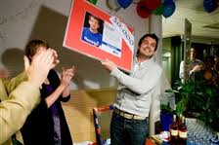](http://nl.wikipedia.org/wiki/Ruben_Nicolai)Our host Ruben Nicolai* Our host [Ruben](http://translate.google.com/translate?hl=nl&sl=nl&tl=en&prev=_t&u=http://nl.wikipedia.org/wiki/Ruben_Nicolai) proved to be a clear-sighted with his personal dream of 50,000 donors. I want to mention him specifically because he had a very big share in the ultimate success. He presented this evening in his unconventional way and was really motivated. The viewers saw this very well and rewarded it with lots of phone calls.

*Buzz* The buzz has been very important to involve people upfront and to generate as many viewers as possible. PR is incredibly important. This was never realized without the support of many celebrities. The campaign song was very important for creating this buzz and the special t-shirts created visibility and underlined the feeling for taking action and responsibility.

*Dare to ask* Fundraising is about 'dare to ask’ and of course at the right person at the right time, through the proper channel in the right tone of voice. If you do not ask, you won’t get anything.

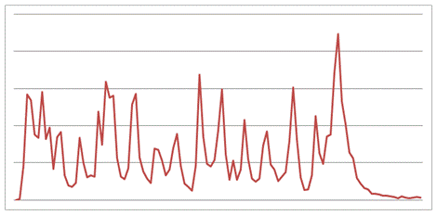

The above graph shows the number of inbound calls during the show. Also in this TV show there’s a clear correlation between an appeal and response: actually there was an almost constant peak, but the most calls were the result of an appeal. Don’t be afraid to mention the telephone number a lot and certainly don’t wait too long with your first appeal. Again, the largest peak was at the end of the show. It is important to mention a target at the start of the show , to inform the viewer frequently about the results and involve the viewer actively to reach the target together.

[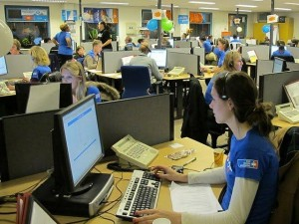](http://www.101fundraising.org/wp-content/uploads/2011/02/foto-belvloer.jpg)

Whether you have to mention only a telephone number for responding? Before this show, we did thought this was wise to do so because it’s KISS (keep it simple and stupid). But without explicitly mentioning the website actually, a considerable amount of people signed up online. The TV show was very effective in generating online traffic and social media generated a significant volume of that traffic: a lot of tweets were send that night. Social media are really potential for structural traffic and this caused a lot of online donors while these people might not even watched the show if they didn’t receive a tweet about the show.

Finally, I emphasize that it is rather elementary to have enough call agents. There were so many volunteers who did help in the several call centers of [SNT](http://translate.google.com/translate?hl=nl&sl=nl&tl=en&prev=_t&u=http://www.snt.nl/). Simply because you're dealing with big peaks, you will always have to capture calls through the voice response. It is critical to call these people as quickly as possible, it’s really obvious but you have to take this into account in your planning: these hot leads must naturally not cool down, because the longer you wait the lower the conversion rate.

[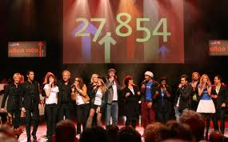](http://www.101fundraising.org/wp-content/uploads/2011/02/foto-podium.jpg)Within KWF we are thinking about several scenario’s about the follow-up. Perhaps other international cancer related organizations see possibilities for co-operation. Personally I am very curious about the experiences of others regarding fundraising through television.

**Who will stand up to share his or her experiences and learnings?**

Lars is Marketing Manager at the Dutch Cancer Society (KWF Kankerbestrijding), member of the Strategic Board of the [DDMA](http://www.ddma.nl) (Dutch direct marketing association) and member of the marketing committee of [VFI](http://www.vfi.nl) (association of Dutch non-profit organizations). Previously worked for several commercial companies in several industries (mail order / distance selling, airline, leisure, television & lottery)