**Why you should considering a telethon**

2011 was a very special fundraising year for the Dutch Cancer Society (KWF Kankerbestrijding) in which over € 130 million was raised. That’s an increase of over 20% versus last year. Especially income from legacies, [Alpe d'HuZes](http://translate.google.com/translate?hl=nl&prev=_t&sl=nl&tl=en&u=http://deelnemers.alpe-dhuzes.nl/acties/larsarnoldussen/lars-arnoldussen/donaties.aspx%3Fmode%3Dinvoice) ( a major cycling fundraising event which generated € 20 million in 2011) and income from private donors led to this significant increase.

An important way for the Dutch Cancer Society to recruit donors is the campaign "Stand Up To Cancer" in which a telethon has a major role. TV is for the Dutch Cancer Society an almost steady part in the multichannel mix to recruit donors and this was the fifth telethon since 2006.

In 2010, for the first time the "Stand Up To Cancer" concept was used and this campaign resulted in no less than 50,000 structural donors. That was an amazing result and far beyond everybody’s expectations. The fundraising potential of this concept was clearly demonstrated. I wrote [blog](http://www.101fundraising.org/2011/02/dutch-cancer-society-recruits-50000-donors-telethon/) about it last year. Consider this as part two so it could be helpful if you read the first one.

With this concept funds will be raised to accelerate groundbreaking research that can get new therapies to patients quickly, enabling (inter)national scientists to work together. "Stand Up To Cancer" is an invitation and symbol of a movement of people who come in action and stand up in the fight against cancer. Important is the personal reason to stand up for someone in particular and the personal relation towards cancer. The concept offers all the ingredients for effective marketing communication: modern, active, inspiring, intense, authentic, passionate.

In November 2011, a cross-media fundraising campaign was executed with again an important role for a telethon. And also this time the Netherlands rose en masse against cancer and in total more than 45,000 people became regular donor. If you have missed the telethon, it still can be seen via this [link](http://player.omroep.nl/?aflID=11728214) or search within YouTube for 'Sta op tegen kanker' (Stand up to cancer) to watch several high lights.

The campaign was much more than a single-play 90-minute telethon. There was a huge buzz and awareness upfront the telethon in order to involve as many people as possible. In addition, during this period also donors and volunteers were recruited through other media.

***Awareness***

The campaign song generated a lot of attention and free publicity in advance. A famous Dutch singer (Jeroen van de Boom) did release a single especially for the Dutch Cancer Society and resulted in a number 1 hit. He did represent the Dutch Cancer Society very well in the various media.

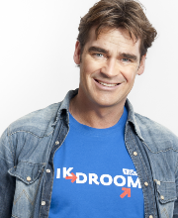

Additional attention to social media generated that #staoptegenkanker (stand up to cancer) became number 1 trending topic on the day of the telethon and that many people shared their impressive personal stories and photographs on our facebook account. These were also shown during the telethon.

*Other fundraising activities*

During this period, a part of the campaign focused on recruiting volunteers and promoters to organize fundraising campaigns. Furthermore several below-the-line actions were executed to recruit regular donors, such as affiliate marketing, direct dialog, telemarketing, direct mail and the online platform www.staoptegenkanker.nl was further optimized.

*The telethon*

The telethon was the main part of the overall campaign and was broadcasted on 16th of November 2011. Personal stories of (in)famous people were the central theme: all the people in the show mentioned explicitly for whom they particularly literally stand up against cancer. The frank statements were common thread throughout the program. There were emotional patient stories and special live performances.

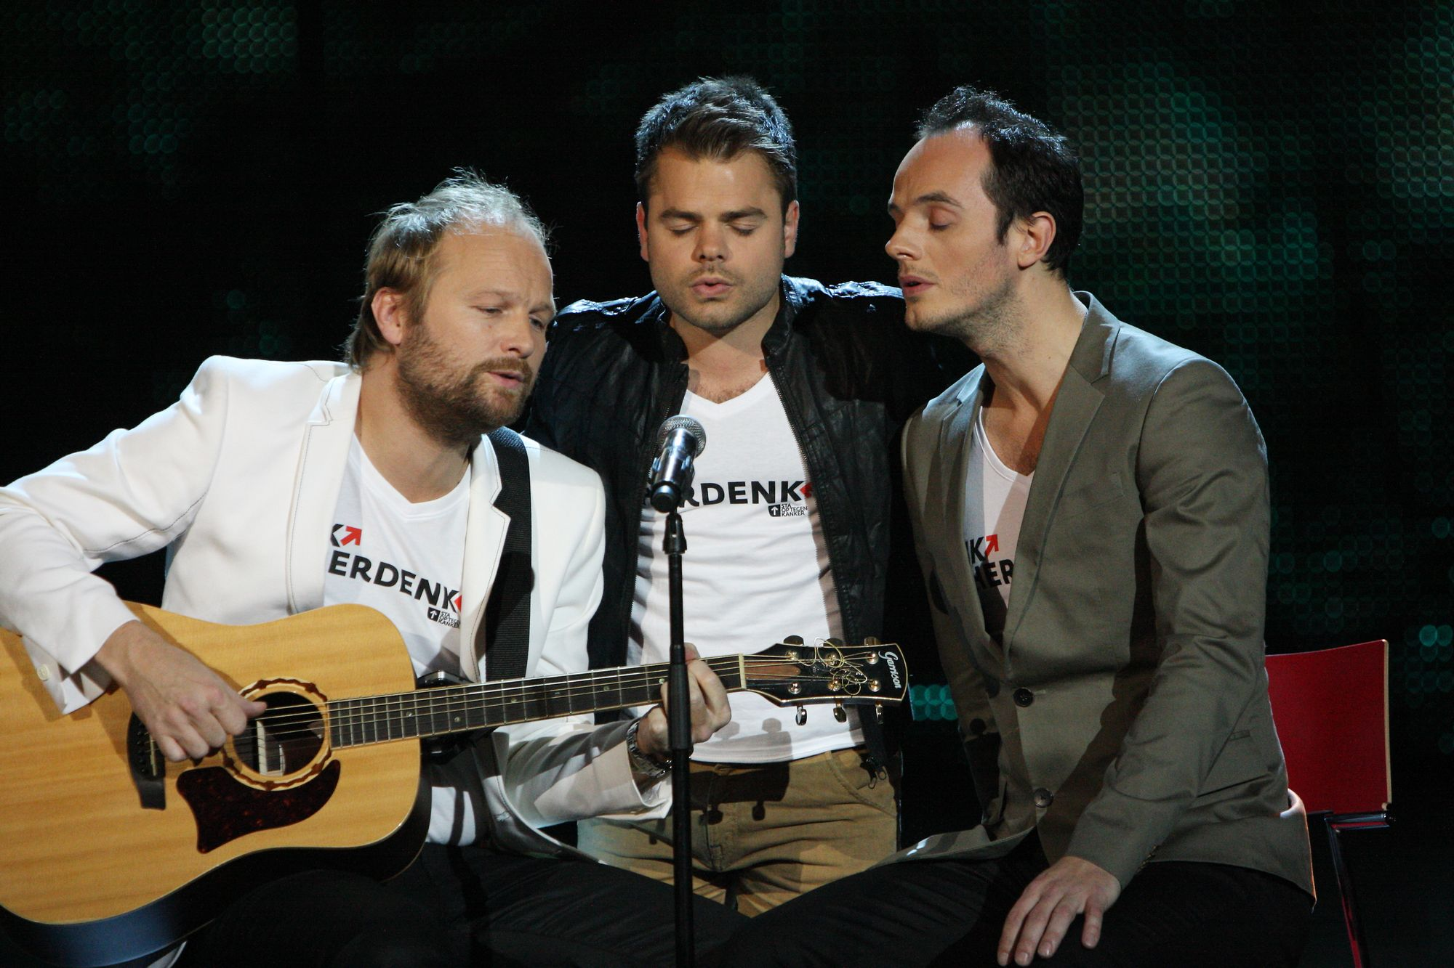

Due to the big media attention, the telethon attracted many viewers (1.153 million) and the market share (17.3%) was very good. The show was rated above average by the viewer and was a few minutes before the end timeslot winner. This is really important to acquire any future primetime timeslot.

But definitely also a critical sound: a telephone number was used as the main response channel and at various moments during the telethon less inbound calls were received than expected. Compared to the telethon in 2010, the edition in 2011 generated less intense peaks. The graph below shows the differences in the number of inbound calls per minute of the broadcast in 2010 and 2011 (red line).

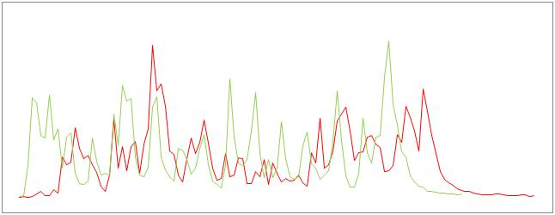

As mentioned before, telephone was the main response channel. But in the queue of our call center and at few moments during the show the website www.staoptegenkanker.nl was mentioned and viewers were asked to tweet #staop (stand up). In total approximately 20% registered online and 80% via the telephone.

**Fundraising through a telethon**



The response rates of below-the-line actions are relatively easy to predict. The result of a telethon remains a difficult phenomenon to predict. Below my top 10 of success factors.

1. Inspiration and passion of a lot of people: the engine behind many beautiful things in life.
2. Cooperation between the NGO, broadcasting and production company. Especially when working with multiple external parties creating the right and open atmosphere is necessary: working together as one close team with the same goals and that has respect for everyone's expertise. The beautiful cooperation with the broadcast company [AVRO](http://www.avro.nl), the producer [I Care](http://www.icareproducties.nl) and agency [WWAV](http://www.wwav.nl) had a very important contribution to the final result.
3. Not a single play telethon, but preferably as part of a bigger integrated cross-media campaign
4. A very strong format that touches people right in their hearts.
5. Lots of free publicity and buzz upfront to attract as many viewers as possible. A campaign song can be very effective to create awareness.
6. The contribution of celebrities and not just because they are celebrities but only celebrities who have a clear and really sincere link to your cause. It this is not the situation, you can better ask less famous people who are really passionate about your cause: authentic story telling is key.
7. Your cause should of course be relevant and appealing to a wide audience because of the mass media communication.
8. Fundraising is about daring to ask: the goal is not a beautiful show, but a fundraising show with a beautiful result that obviously contributes to the positioning of your brand. And always rely on your own fundraising expertise as you do this when assessing the fundraising power of other actions.
9. Use both telephone and online as response channel. The main response mechanism was by telephone, but without mentioning the online response option many times around 20% of all new regular donors registered online as a new supporter.
10. Use the fundraising expertise of your people, put a dedicated multi-disciplinary team in a clear project structure. This is not a project that can easily be done on top off all the regular activities of your employees.

***Why you should considering a telethon?***



If you have any plans for a telethon or should some people be convinced, maybe that below arguments can help you.

1. It can be a very cost effective way to recruit donors and thus make an important contribution to achieve your mission.
2. Via telethon recruited new donors have a lower average churn rate compared to other channels and a higher lifetime value.
3. It's a beautiful way to present your organization and mission to a big target group and it can boost your brand and desired positioning.
4. It has a binding effect to the existing supporters and partners and it can stimulate them to continue or even increase their support.
5. If it’s part of a bigger cross-media campaign the telethon may increase the ROI of other fundraising activities.
6. A telethon can have the function of a catalyst and can create new (fundraising) opportunities such as for example contacts with new possible companies or major donors.
7. It creates a nice dynamic outside and inside your organization, it creates involvement from a lot of people, it connects colleagues and generates a positive spirit within your organization.

In the meanwhile we are starting up for a new campaign at the end of this year. Our American partner EIF has a telethon planned for early September and perhaps there will be more European cancer organizations executing a telethon this year and adopt the "Stand Up To Cancer" concept in order to accelerate groundbreaking cancer research.

Finally I have two pressing questions:

1. Various charities (f.i. Unicef, WWF, Red Cross) also have experience with telethons.

Who will stand up to share his or her experience?

1. At the beginning of this blog, I did mention the fundraising cycling event Alpe d'HuZes.

Participants will bike the famous and giant mountain Alpe d’Huzes 6 times in a day individually or as a team and raise funds for cancer research. To give you an idea about the height: that’s in total 20 times the Eiffel Tower. Donations give my efforts really worth! Will you join and support me on this beautiful, but certainly very painful and most unforgettable day?

Will I see you on my [personal page](http://deelnemers.alpe-dhuzes.nl/acties/larsarnoldussen/lars-arnoldussen)?